1. check whether the following function is a valid probability density function.

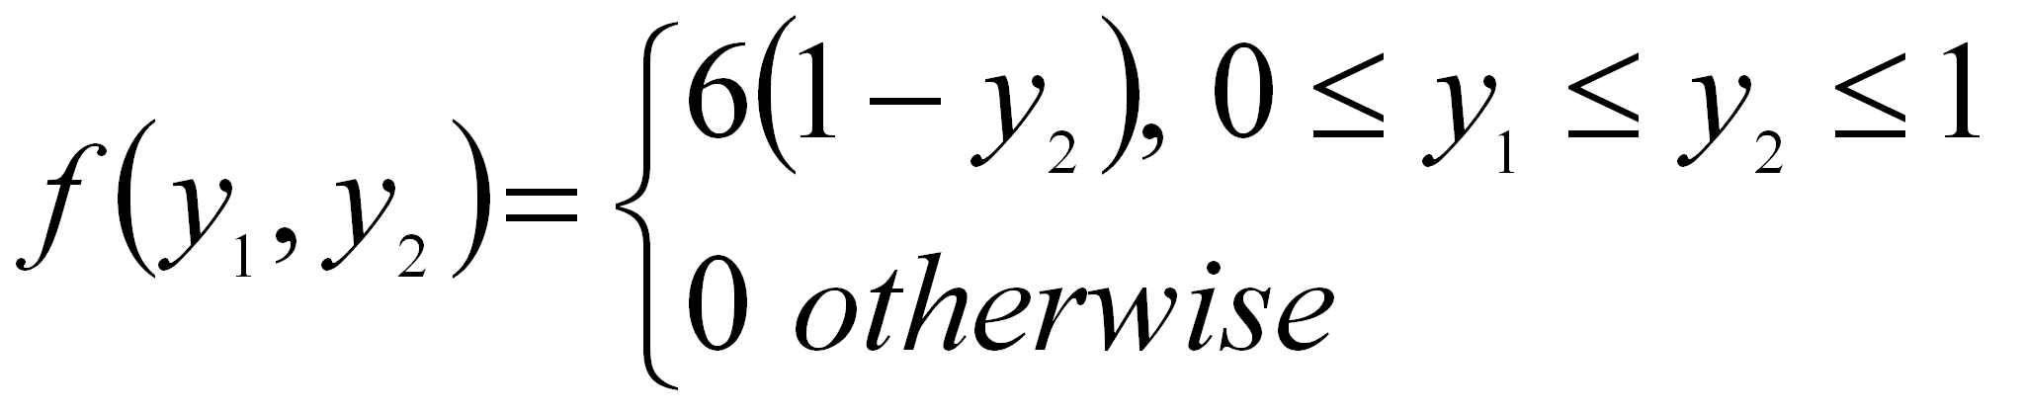

2. Gasoline is to be stocked in a bulk tank once at the beginning of each week and then sold to individual customers. Let Y1 denote the proportion of the capacity of the bulk tank that is available after the tank is stocked at the beginning of the week. Because of the limited supplies, Y1 varies from week to week. Let Y2 denote the proportion of the capacity of the bulk tank that is sold during the week. Because Y1 and Y2 are both proportions, both variables take on values between 0 and 1. Further, the amount sold, y2 cannot exceed the amount available, y1. Suppose that a model for the relative frequency histogram for Y1 and Y2 is given by

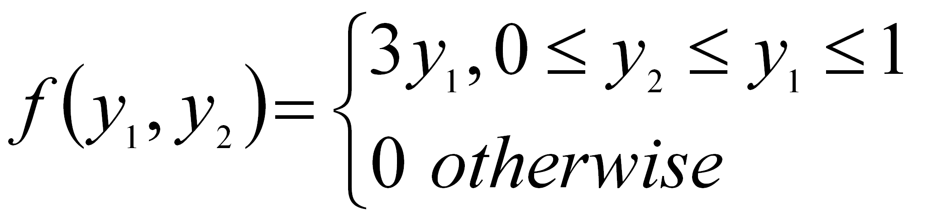

Find the probability that less than one half of the tank will be stocked but more than one-quarter of the tank will be sold.

3. a) Explain the procedure of constructing various graphs using SPSS.

(b) The following is an output obtained from SPSS. Identify the diagram, and write the procedure.

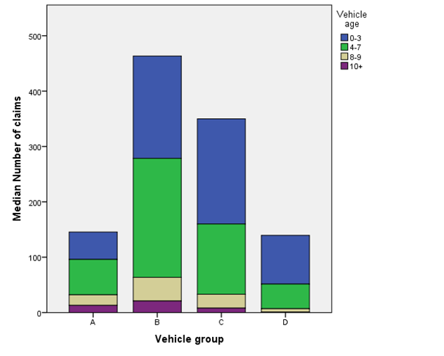

4.

|  |  |  |  |  |  |  |  |  |  |  |  |  |  |  |  |  |
| --- | --- | --- | --- | --- | --- | --- | --- | --- | --- | --- | --- | --- | --- | --- | --- | --- |
| (a) Find the value of k given the following probability distribution and then obtain its mean and variance.   |  |  |  |  |  |  | | --- | --- | --- | --- | --- | --- | | X | 2 | 4 | 6 | 8 | 10 | | P(X) | 1/12 | k | 1/3 | 1/4 | 1/6 | |  |  |  |  |